**Laser Project**

**125 poker chips and carrying box**

**2-sided chips**

**Prepared for Bainbridge BARN, ETA Studio - bainbridgebarn.org**

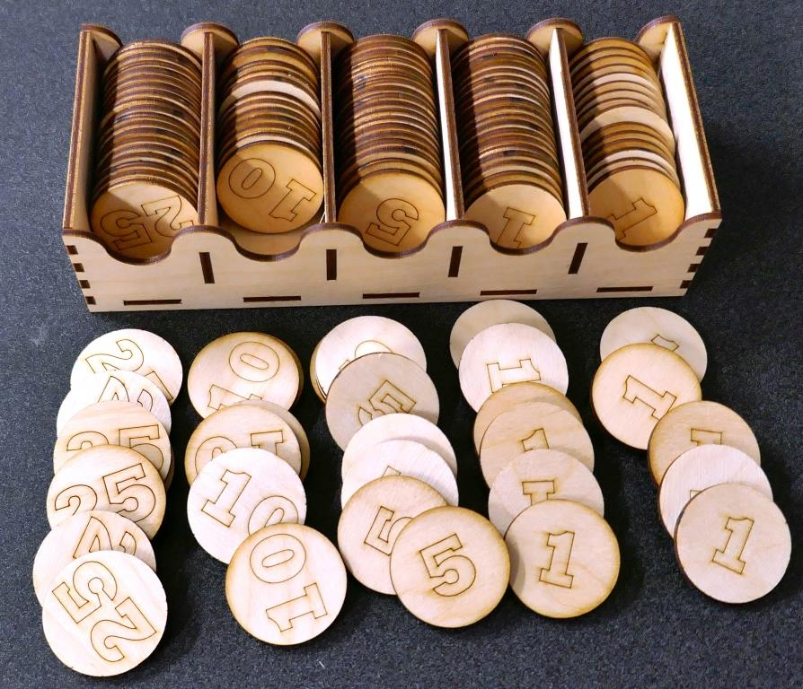

# Overview

In this project, you will use 2 pieces of 300mm x 500mm raw material to make 125 poker chips, plus a box to store them in. You'll make 50 chips with "1", and 25 each of "5", "10", and "25", plus a few extras in case some turn out to be losers. Total etching and cutting takes a total of about 30 minutes on Little Blue and 20 minutes on Big Red, but figure 1-1.5 hours to complete the project.

# Material required

* 2 sheets 300 x 500 3.2mm thick MDF or Plywood
* White glue

# Difficulty level - Medium

The project is judged medium difficulty because each of the pieces of material is engraved twice so the chip values are engraved on both sides of each chip. This is a great place to learn how to do two-sided engraving , and each step is described and explained.

|  |
| --- |
| **Safety First**   1. **Always follow the safety procedures you learned in the laser class.** 2. **Steps for using the laser are posted. Follow them.** 3. **We were all beginners once. If you have a question, ask a monitor for help.** 4. **Never try to run the laser with the lid open.** |

Let's get started…

**TASK 1 - Get prepared**

|  |  |  |
| --- | --- | --- |
| **1** | Get two pieces of material that are 300mm x 500mm. These can be purchased from the ETA studio material stock cupboard. 3.2mm Baltic Birch plywood is recommended, but MDF will also work. You can also be really fancy and cut your chips from acrylic. | Ask the studio monitor for assistance purchasing the material. |
| **2** | Measure your material thickness using calipers. We have LightBurn files for 3.2mm (1/8") and 3.0mm. | Knowing the material thickness is important because the thickness of the material determines the size of the holes in the box and also the overall size of the box. |
| **3** | Download two files from the ETA github projects folder – "96 pokerchips – 2 sided.lbrn" and "chip box + 32 chips – 2 sided.lbrn" LightBurn files. | Be sure to get the files from the directory with the size that matches your material thickness. |

**AN EDUCATIONAL INTERLUDE….**

**2-sided engraving - The method behind the madness**

Etching on both sides of a piece of material has a challenge – how do you make sure the material is "lined up" correctly under the laser when you work on the second side? In our case, we want the values on both sides of each chip to be centered on the chip. Being off by a little bit might be OK, but being off by a lot could be a waste of a piece of material. In this project, you'll learn a method that makes this easy. You'll do a little fancy footwork in both LightBurn and on the laser that will allow you to etch one side of your material, then flip it over and position it perfectly so that the etching and cuts on both faces are aligned.

This section talks about the method of doing a successful flip. Nothing to do here but learn. The following section will walk you through making your chips and box.

The requirements of a successful (well aligned) flip are:

1. Getting the material in the correct X position after the flip.
2. Getting the material in the correct Y position after the flip.
3. Keeping the material from rotating after the flip.

There are a lot of ways to do this, but this is the one I like. I'll walk you through the steps, illustrating with a sample cut I made on a piece of scrap material.

The basic idea is this:

1. Put your material in the laser and hold down one edge securely on the bed.
2. Engrave the first side.
3. Cut your material into two pieces, with a carefully crafted line.
4. Leave the part that you secured and flip the other part over, using that carefully crafted cut to align the piece you flipped.

Let's talk about that "carefully crafted" cut. In LightBurn, it looks like the picture below. The pink rectangle represents my raw material, and the black line with the two points on it is the carefully crafted cut. That skinny part of the material above the cut us what we'll be holding securely to the bed. The bottom part is where our final part will be made.

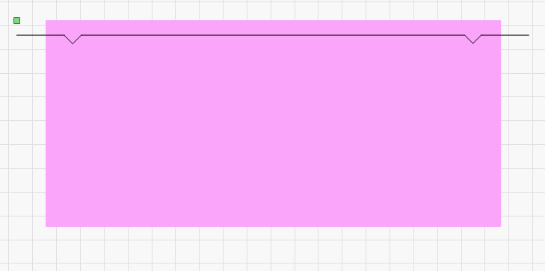

The requirements of this "careful crafting" are:

* The points be precisely the same shape (so the material will fit together when it's flipped over)
* The cut line is wider than the material. If not, the laser will not cut the top and bottom apart.
* There is no object to the right or left of the cut line. We'll use this fact to flip the design in LightBurn when we flip the material.
* The short lines to the right and left of the points are the same length. This makes flipping easy in LightBurn.

OK, let's look at a real example. For my first side, I am etching some text and cutting two boxes, as shown below. Notice that I've named my layers - S1 or S2 for which side, and etch vs cut. And they are ordered etching first, cutting last. Also, I've got the second side objects (S2) Output and Show turned off. Show is for clarity, Output is so I don’t etch the bottom on the top.

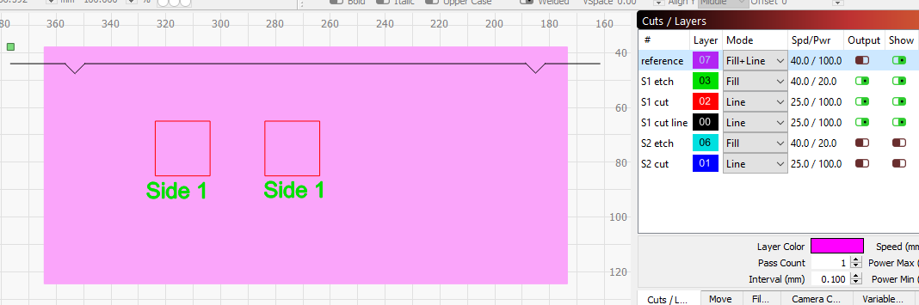

On the laser, I start by placing the material against the back edge of the laser's bed, pushing it up against the edge of the frame, then use blue tape to tape it to the frame of the laser bed. There are other (probably better) ways to attached it to the bed, but this is what I did for this example. The picture below was taken after the cut was done. Notice that the laser is positioned off the material and the "carefully crafted" line has split the material in two.

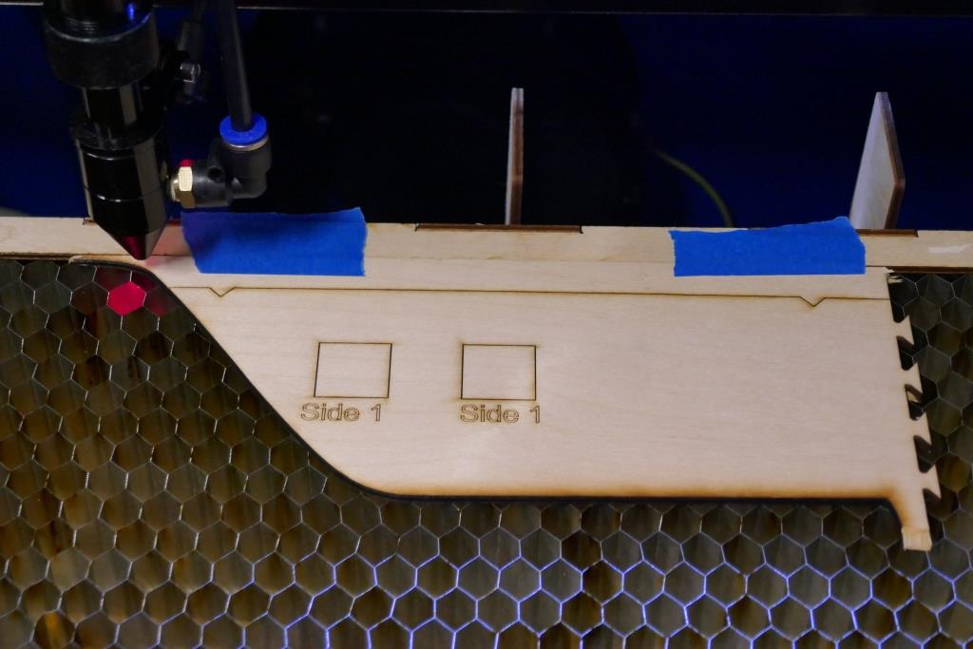

Now I can pick up the bottom half and flip it over. For this example, I used blue tape again to tape the pieces together. Now I'm ready to lase the second side. Let's take a look at LightBurn again. This is where the fancy footwork comes in.

First, since I flipped my material, I need to flip the design in LightBurn to match. I do this by turning "Show" ON for all layers, selecting EVERYTHING and using the right/left mirror function. If you don’t' turn "Show" on before selecting all your objects, the un-shown objects will not be selected, and they will not be mirrored.

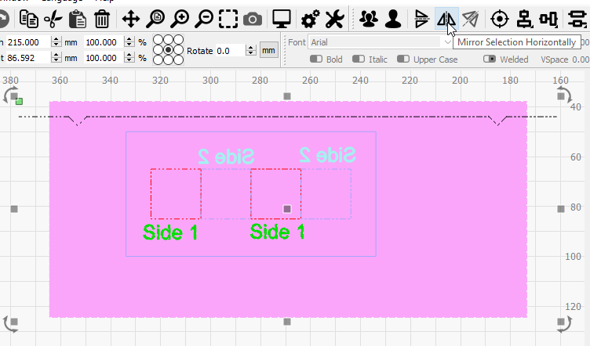 becomes 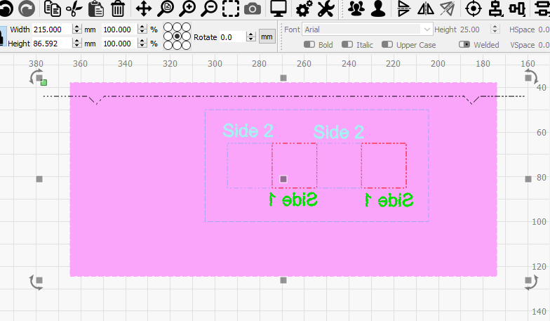

Mirror

Notice that the writing from Side 1 is reversed and the red squares are now on the right. You can also see the rest of my example design - some etched text and two more squares cut out, that are aligned with the first to – to be able to check on the alignment.

Before we cut, we need to set Output of the S1 object off and the S2 objects to ON. I also set Show OFF on those objects just to make it clearer and help me not laser the side 1 things by accident – which I have done plenty of times by accident.

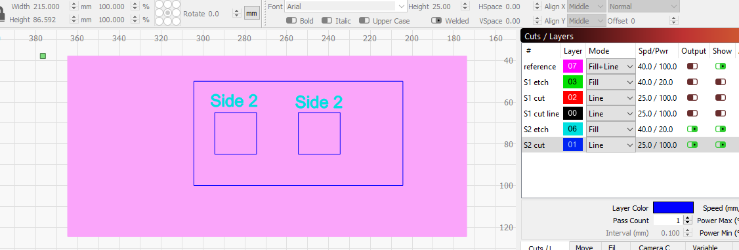

Now we Start the laser and let it do it's thing. The result is below. You can see where I've used blue tape to tape the two sides back together after the flip.

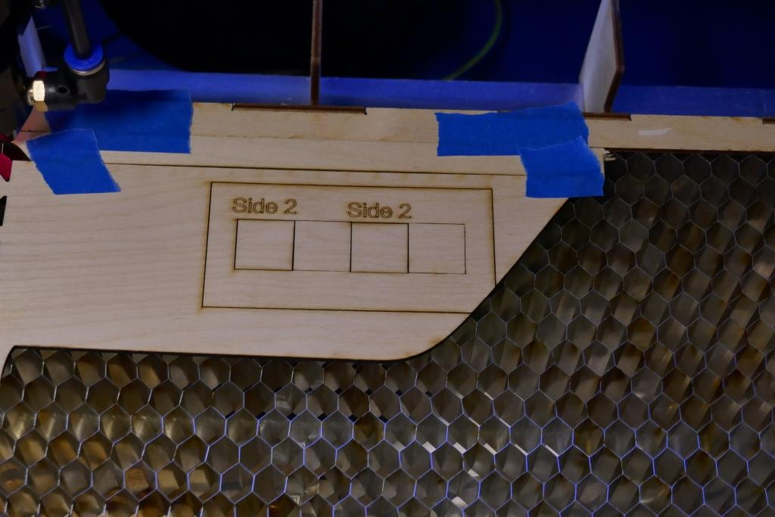

Let's take a close look at the alignment of the through cuts. You can see that they are not quite perfect. In fact, they are off by the amount of material we burned out on the cut we flipped against – the kerf. I measured this to be .015mm. We could have improved our alignment by moving those squares on side 2 up by this amount to compensate. But's we'll call this good enough for now.

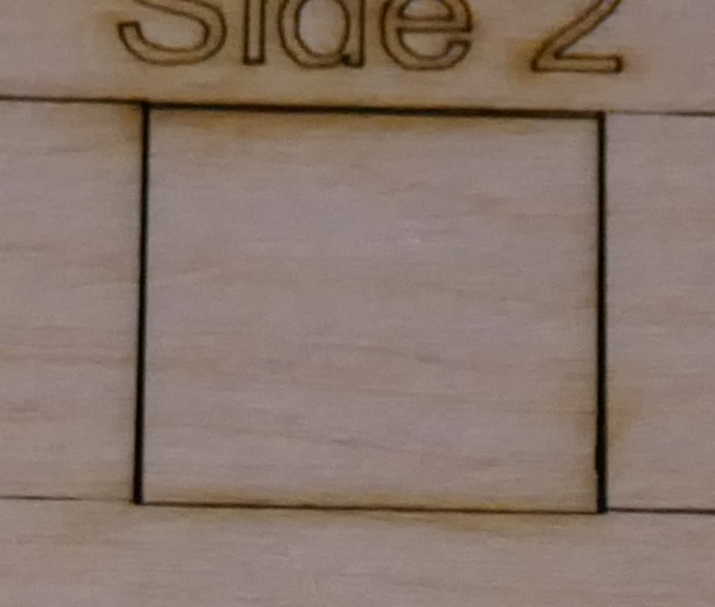

That's the theory, let's make your poker chips with the values on both sides.

**TASK 2 – Cutting and Engraving the first sheet**

|  |  |  |
| --- | --- | --- |
| **1** | Open the file: "96 poker chips – 2 sided.lbrn"  Note that only layers 01 and 09 have Output turned ON (slider is green).  These are what we will be lasing on the first side of our material. |  |
| **2** | Put the material on the bed.  If you are using a 300 x 500 sheet of material and Little Blue, you will need to cut notches in the two rear corners of your material. These notches should be about 10mm x 10mm. This is needed so the cut line will go off the material.  Place the material with the notched long edge against the rear edge of the bed frame and tape it to the frame together along this edge. Try to overlap the blue tape on the material by only about 5mm.  Use clips on other edges of the material if needed to hold it flat to the bed. |  |
| **3** | Laser the first side.  Power up the laser following the posted steps. Always follow laser safety rules.  If you are using Big Red, you will need to adjust the speed and power of the laser for both the cut and etch lines. Refer to the material library for recommended settings.  Focus the laser on your material  Position the laser so the red dot is in the notch on the left side, ideally, just past the blue tape.  Ensure that the Laser window shows "Start From: Current Position"  Use the Frame button to ensure the laser stays on your material on all edges.  It should etch the numbers for the chips, then cut the material free along the flip line.  DO NOT move the laser. | If you are really, super new to using the laser, or it's been a while, don’t hesitate to ask the monitor to review the laser safety and use steps with you. |
| **4** | Flip the material.  Leaving the piece that is taped to the frame, remove the rest of the material, flip it over and push it gently up against the taped piece, aligning the triangular notches. Use blue tape to hold it in place. You don’t need to tape the full length, just the two back corners.  Use clips to hold down the edges of the material if it is not flat on the bed. |  |
| **5** | Back in LightBurn, flip the design.  Turn Show ON for all layers.  Select everything in the design and use the left/right mirror button to mirror it. |  |
| **6** | Turn OFF Output and Show for the side 1 layers (01 and 09).  Turn ON Output and show for the Side 2 layers (15 and 00).  Verify that Layer 00 is below Layer 07 in the Cuts/Layers window. |  |
| **7** | Laser the second side.  Follow posted safety procedures.  No need to focus, or position the laser this time.  Frame the cut.  Start the laser. It should etch the numbers on all the chips then cut them out. |  |
| **8** | Remove your chips, the scrap material and the edge material you taped to the frame. |  |
| **9** |  |  |

**Task 3 - Cutting and engraving the second sheet**

|  |  |  |
| --- | --- | --- |
| **1** | Open the "chip box + 34 chips – 2 sided.lbrn" file. It should look like the image on the right. Again, you might need to mirror the image if you are cutting on Big Red.  On this sheet, you'll cut out the remaining chips and the parts for the box.  Note that the box parts are all labelled, but the labels are on layer 07 (the Reference layer), and this layer has "Output" turned off, so we won’t be putting the labels on the finished parts. |  |
| **2** | Follow the same steps you did for the first sheet (Task 2), and you'll have all your chips and all the box parts. |  |

**TASK 4 - Assemble the box**

|  |  |  |
| --- | --- | --- |
| **1** | Fit test - We'll use white glue to glue the box part together, but it's best to "dry-fit" the parts together to see if there are any tight fits that need to be trimmed slightly. Follow the steps below, without glue, then take it apart and apply the glue as you assemble it again. The pictures show the recommended glue locations/ |  |
| **2** | Put spacers in the bottom of the box.  You can use glue on these or skip it, since the spaces are completely captured by the sides. I recommend glue because it makes the finished box stronger. | C:\Users\ms\AppData\Local\Microsoft\Windows\INetCache\Content.Word\Box assy 1.jpg  Box assy 2 |
| **3** | Put the first side on – both sides are identical, but will slip together more easily if the side that was "up in the laser is on the inside of the box.  Add glue to the top edges of the bottom and spacers and stick on one of the sides. You'll need to move the spaces a bit to get them to align with the holes in the sides. | P1000862  C:\Users\ms\AppData\Local\Microsoft\Windows\INetCache\Content.Word\Box assy 4.jpg |
| **4** | Glue on one end. I recommend putting glue on the surfaces of the main piece, not the piece you are adding. It's less mess that way. | E:\Mike\BARN\Laser\project - 125 poker chips\pictures\Box assy 5.JPG  C:\Users\ms\AppData\Local\Microsoft\Windows\INetCache\Content.Word\P1000865.jpg |
| **5** | Glue on the other end the same way. | C:\Users\ms\AppData\Local\Microsoft\Windows\INetCache\Content.Word\P1000866.jpg |
| **6** | Finally glue on the last side. This is the trickiest side to get on because of the need to align all the tabs. But your dry-fit give you practice.  Set this assembly aside and wait for the glue to dry. | C:\Users\ms\AppData\Local\Microsoft\Windows\INetCache\Content.Word\P1000867.jpg  C:\Users\ms\AppData\Local\Microsoft\Windows\INetCache\Content.Word\P1000868.jpg |

That's it, you're all done. We hope you've enjoyed the experience and sharpened your LightBurn and laser cutter skills in the process.